**Following are the issues identified:**

1. For rule 1 and 2 error message still in the screen for Yes options

Step to reproduce

1. Ques1- Click on Yes
2. Ques2-Click on No
3. Ques2-Click on Yes
4. Click on Proceed.

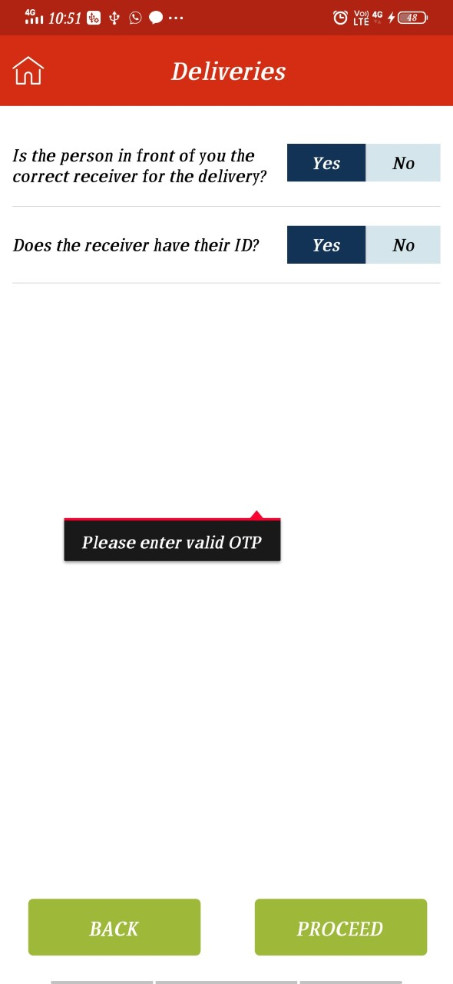

1. Enter OTP Number error message displays in Non-Delivery screen

Steps to reproduce

1. Select waybill with POD

2. Ques1-Click on Yes

3. Ques2-Click on No

4. On pop-up click No than Yes

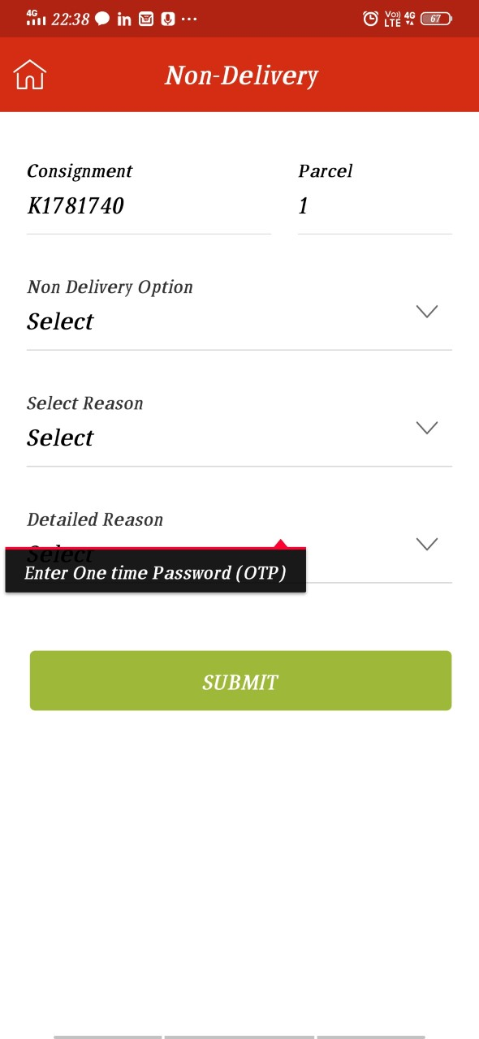

1. Please Look into below screen shots -found these issue while testing , these are randomly seen so don’t have step to reproduce

1.

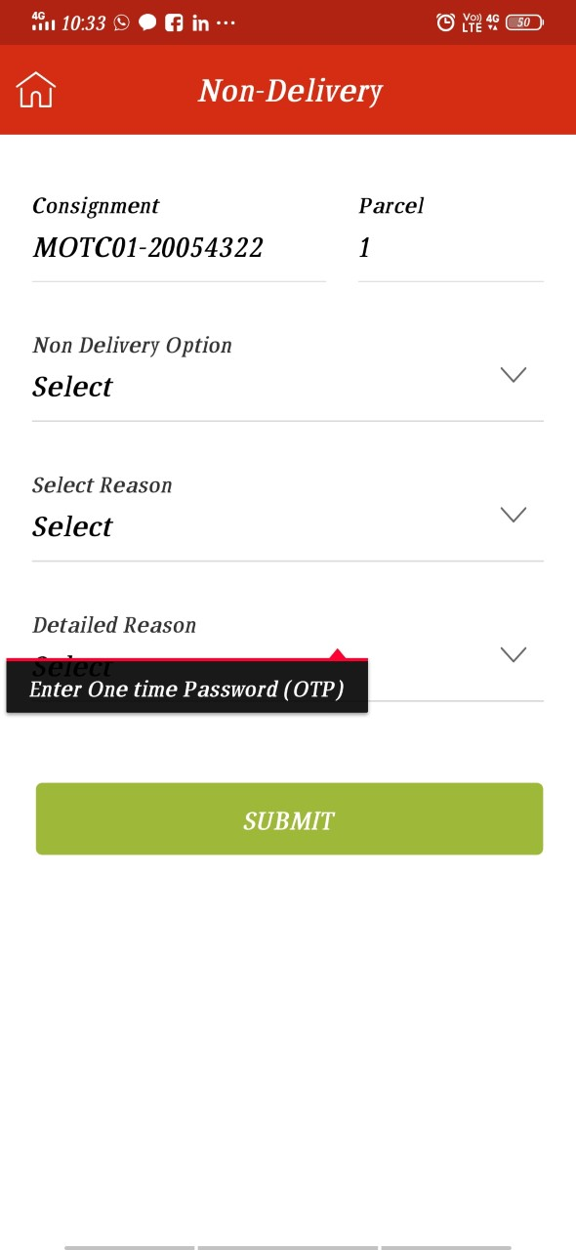

2.

2. 

4. Can we do something for fragment reset issue- Multiple times found issue of questions reset while testing

5. Enter GRV number field and Input Receiver's Name field should not special characters.